**Green Society Public School**

**D-20**

**Ratnanagar-7, Sauraha, Chitwan**

**First Terminal Examination-2082**

**Class: L.K.G Time: - 2 hrs. F.M.: 50**

**Sub: Social Science P.M.: 18**

|  |
| --- |
| **Name: Roll No.: Sec.:** |
| **­­­­­­­­­­­­ ________________ ______________ OBT.MARKS:**  **INVIGILATOR EXAMINER** |

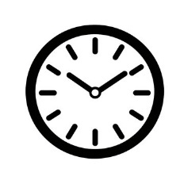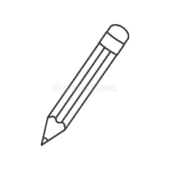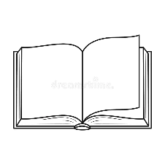**(1) Write the first letter of the given pictures. [3]**

__________ ___________ ___________

**(2) Fill up the missing letters.** **[3]**

(a) A _ p _ e  
(b) B _ n _ _ a  
(c) M _ n _ _

**(3) Write 's' for small and 'B' for big ones. [5]**

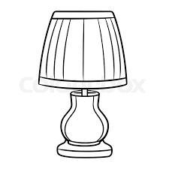   

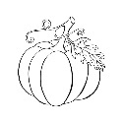 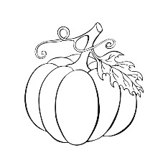  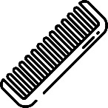

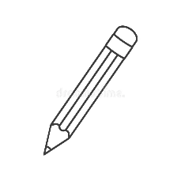 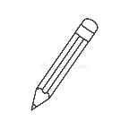

**(4) Circle only vegetables. [5]**

**(5) Match the sense organ to correct picture. [5]**

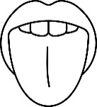 

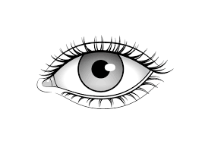 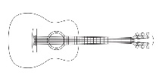

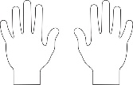 

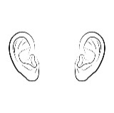 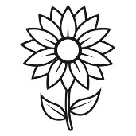

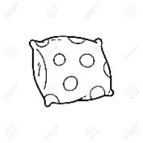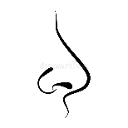

**(6) Tick (✔) the correct word for each picture. [5]**

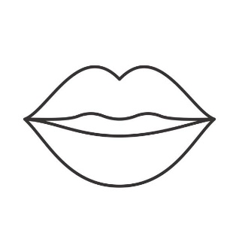

Lips Foot

Head Nose

 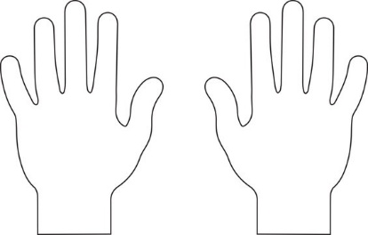

Eyes Hands

Mouth Teeth

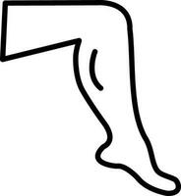

Fingers

Leg

**(7) Write 'G' for good habits and 'B' for bad habits. [6]**

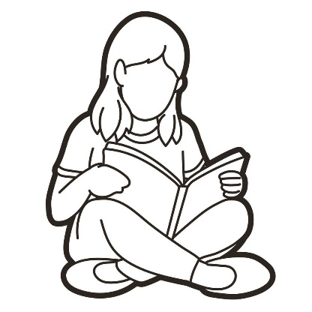 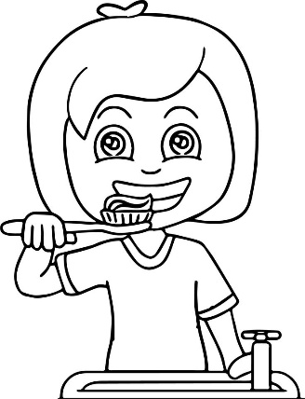

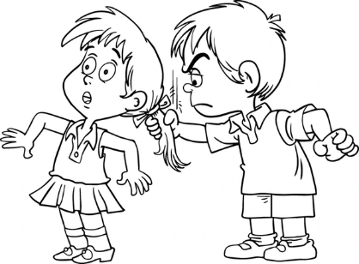 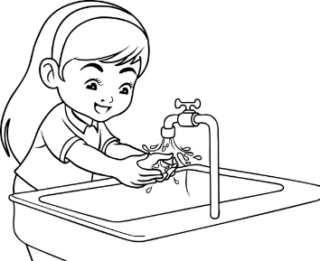

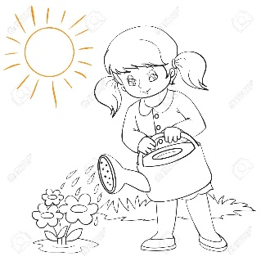

**(8) Match the correct picture. [6]**

Nose 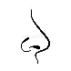

Ears 

Mouth 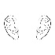

Hands 

Eye 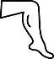

Leg 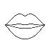

**(9) Circle the similar words. [6]**

Grandfather = Father   Grandfather

Mother = Mother   Grandmother

Brother = Sister    Brother

Sister = Mother   Sister

Book = Book     Bag

Colour = Chair     Colour

**(10) Count and write. [6]**

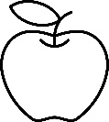  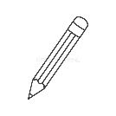

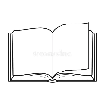 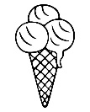



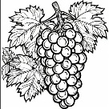

 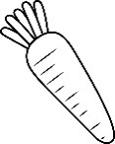



**The End**